**Ideation Phase**

**Define the Problem Statements**

|  |  |
| --- | --- |
| Date | 19 September 2022 |
| Team ID | PNT2022TMID36162 |
| Project Name | Project - Fertilizers Recommendation System For Disease Prediction |
| Maximum Marks | 2 Marks |

**Customer Problem Statement Template:**

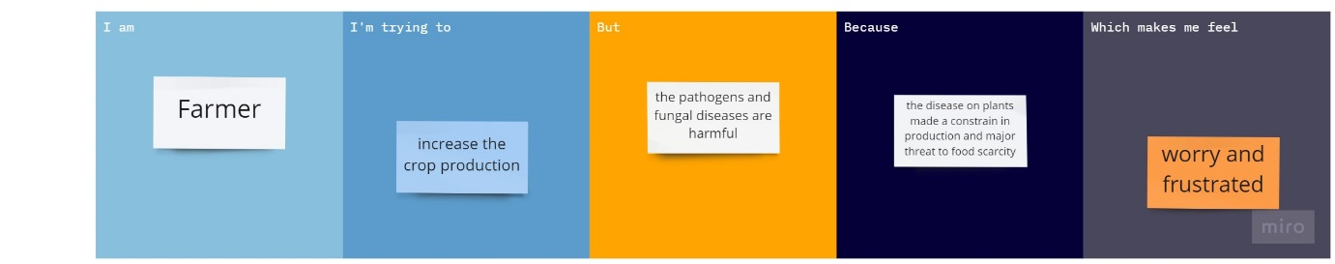

|  |  |  |  |  |  |
| --- | --- | --- | --- | --- | --- |
| **Problem Statement (PS)** | **I am (Customer)** | **I’m trying to** | **But** | **Because** | **Which makes me feel** |
| PS-1 | Farmer | Increase the crop production | The pathogens and fungal diseases are harmful | The disease on plants made a constrain in production and major threat to food scarcity | Worry and frustrated |
| PS-2 | farmer | Produce healthy plants | Bacteria’s and weeds are grown with the plants | Loss in the minerals of the plants and soil weeds absorb a lot water | helplessness |